May 2020 TOK essay titles

A little “cookbook” that helps you in making connections between key terms, knowledge claims, opposing claims, knowledge frameworks, WOKs, knowledge questions.

Make a copy and start cooking your delicious TOK essay!

|  |  |
| --- | --- |
| [More](https://www.thinglink.com/scene/1230606635991302151) | **Knowledge frameworks for different AOKs (the headings below work as links)**  **#1“Others have seen what is and asked why. I have seen what could be and asked why not” (Pablo Picasso). Explore this distinction with reference to two areas of knowledge.** **3**  **#2 “There is a sharp line between describing something and offering an explanation of it.” To what extent do you agree with this claim?** **4**  **#3 Does it matter that your personal circumstances influence how seriously your knowledge is taken?** **5**  **#4 “The role of analogy is to aid understanding rather than to provide justification.” To what extent do you agree with this statement?** **6**  **#5 “Given that every theory has its limitations, we need to retain a multiplicity of theories to understand the world.” Discuss this claim with reference to two areas of knowledge.** **7**  **#6 “Present knowledge is wholly dependent on past knowledge.” Discuss this claim with reference to two areas of knowledge.** **8**  **Knowledge frameworks** **9** |

|  |  |
| --- | --- |
| Process   1. Choose title 2. Identify key terms 3. Identify the claim made in the title and create the opposing claim 4. Identify relevant part(s) of the knowledge framework, WOKs, and AOK. 5. Identify relevant knowledge questions pertaining to #4 above. 6. Identify perspectives/theories related to #5 above.      1. Ask second order knowledge questions 2. Answer them 3. Conclude | Articulate rich theories of knowledge, reject poor theories of knowledge |

|  |  |  |  |  |  |
| --- | --- | --- | --- | --- | --- |
| **1. Underline key terms appearing in the title****#1“Others have seen what is and asked why. I have seen what could be and asked why not” (Pablo Picasso). Explore this distinction with reference to two areas of knowledge.** | **2. Write here key terms, and related concepts appearing or implied in the essay title.** | **3. Formulate in your own words the claim made or implied in the prescribed essay title.**  **Formulate a claim that is the opposite of that claim.** | **4. Highlight the most relevant aspects of the** [**Knowledge framework**](https://www.thinglink.com/scene/1230606635991302151) **pertaining to this title**   * Scope/applications * Concepts/language * Methodology * Historical development * Links to personal knowledge   **Highlight the most relevant ways of knowing pertaining to this title**   * Sense perception * Reasoning * Language * Memory * Emotion * Imagination * Intuition * Faith | **5. Highlight the areas of knowledge seem particularly good for comparing and contrasting regarding this essay title?**   * Natural Sciences * Human Sciences * History * Ethics * Mathematics * Religious Knowledge Systems * Indigenous Knowledge Systems * Arts | **6. Check the knowledge questions related to those two AOKs that you chose in (5). Could the claims that you wrote in (2) be alternative answers to any of those knowledge questions (with small modifications)? If yes, write those knowledge questions below.**   * [**Natural Sciences**](https://www.thinglink.com/scene/883071920575086594) * [**Human Sciences**](https://www.thinglink.com/scene/883072259156082690) * [**History**](https://www.thinglink.com/scene/883073008149725186) * [**Ethics**](https://www.thinglink.com/scene/883077068756090882) * [**Mathematics**](https://www.thinglink.com/scene/883071344785227778) * [**Religious Knowledge Systems**](https://www.thinglink.com/scene/883073880313298946) * [**Indigenous Knowledge Systems**](https://www.thinglink.com/scene/883074294534373378) * [**Arts**](https://www.thinglink.com/scene/883073384542371842) |
| **1. Underline key terms appearing in the title****#2 “There is a sharp line between describing something and offering an explanation of it.” To what extent do you agree with this claim?** | **2. Write here key terms, and related concepts appearing or implied in the essay title.** | **3. Formulate in your own words the claim made or implied in the prescribed essay title.**  **Formulate a claim that is the opposite of that claim.** | **4. Highlight the most relevant aspects of the** [**Knowledge framework**](https://www.thinglink.com/scene/1230606635991302151) **pertaining to this title**   * Scope/applications * Concepts/language * Methodology * Historical development * Links to personal knowledge   **Highlight the most relevant ways of knowing pertaining to this title**   * Sense perception * Reasoning * Language * Memory * Emotion * Imagination * Intuition * Faith | **5. Highlight the areas of knowledge seem particularly good for comparing and contrasting regarding this essay title?**   * Natural Sciences * Human Sciences * History * Ethics * Mathematics * Religious Knowledge Systems * Indigenous Knowledge Systems * Arts | **6. Check the knowledge questions related to those two AOKs that you chose in (5). Could the claims that you wrote in (2) be alternative answers to any of those knowledge questions (with small modifications)? If yes, write those knowledge questions below.**   * [**Natural Sciences**](https://www.thinglink.com/scene/883071920575086594) * [**Human Sciences**](https://www.thinglink.com/scene/883072259156082690) * [**History**](https://www.thinglink.com/scene/883073008149725186) * [**Ethics**](https://www.thinglink.com/scene/883077068756090882) * [**Mathematics**](https://www.thinglink.com/scene/883071344785227778) * [**Religious Knowledge Systems**](https://www.thinglink.com/scene/883073880313298946) * [**Indigenous Knowledge Systems**](https://www.thinglink.com/scene/883074294534373378) * [**Arts**](https://www.thinglink.com/scene/883073384542371842) |
| **1. Underline key terms appearing in the title****#3 Does it matter that your personal circumstances influence how seriously your knowledge is taken?** | **2. Write here key terms, and related concepts appearing or implied in the essay title.** | **3. Formulate in your own words the claim made or implied in the prescribed essay title.**  **Formulate a claim that is the opposite of that claim.** | **4. Highlight the most relevant aspects of the** [**Knowledge framework**](https://www.thinglink.com/scene/1230606635991302151) **pertaining to this title**   * Scope/applications * Concepts/language * Methodology * Historical development * Links to personal knowledge   **Highlight the most relevant ways of knowing pertaining to this title**   * Sense perception * Reasoning * Language * Memory * Emotion * Imagination * Intuition * Faith | **5. Highlight the areas of knowledge seem particularly good for comparing and contrasting regarding this essay title?**   * Natural Sciences * Human Sciences * History * Ethics * Mathematics * Religious Knowledge Systems * Indigenous Knowledge Systems * Arts | **6. Check the knowledge questions related to those two AOKs that you chose in (5). Could the claims that you wrote in (2) be alternative answers to any of those knowledge questions (with small modifications)? If yes, write those knowledge questions below.**   * [**Natural Sciences**](https://www.thinglink.com/scene/883071920575086594) * [**Human Sciences**](https://www.thinglink.com/scene/883072259156082690) * [**History**](https://www.thinglink.com/scene/883073008149725186) * [**Ethics**](https://www.thinglink.com/scene/883077068756090882) * [**Mathematics**](https://www.thinglink.com/scene/883071344785227778) * [**Religious Knowledge Systems**](https://www.thinglink.com/scene/883073880313298946) * [**Indigenous Knowledge Systems**](https://www.thinglink.com/scene/883074294534373378) * [**Arts**](https://www.thinglink.com/scene/883073384542371842) |
| **1. Underline key terms appearing in the title****#4 “The role of analogy is to aid understanding rather than to provide justification.” To what extent do you agree with this statement?** | **2. Write here key terms, and related concepts appearing or implied in the essay title.** | **3. Formulate in your own words the claim made or implied in the prescribed essay title.**  **Formulate a claim that is the opposite of that claim.** | **4. Highlight the most relevant aspects of the** [**Knowledge framework**](https://www.thinglink.com/scene/1230606635991302151) **pertaining to this title**   * Scope/applications * Concepts/language * Methodology * Historical development * Links to personal knowledge   **Highlight the most relevant ways of knowing pertaining to this title**   * Sense perception * Reasoning * Language * Memory * Emotion * Imagination * Intuition * Faith | **5. Highlight the areas of knowledge seem particularly good for comparing and contrasting regarding this essay title?**   * Natural Sciences * Human Sciences * History * Ethics * Mathematics * Religious Knowledge Systems * Indigenous Knowledge Systems * Arts | **6. Check the knowledge questions related to those two AOKs that you chose in (5). Could the claims that you wrote in (2) be alternative answers to any of those knowledge questions (with small modifications)? If yes, write those knowledge questions below.**   * [**Natural Sciences**](https://www.thinglink.com/scene/883071920575086594) * [**Human Sciences**](https://www.thinglink.com/scene/883072259156082690) * [**History**](https://www.thinglink.com/scene/883073008149725186) * [**Ethics**](https://www.thinglink.com/scene/883077068756090882) * [**Mathematics**](https://www.thinglink.com/scene/883071344785227778) * [**Religious Knowledge Systems**](https://www.thinglink.com/scene/883073880313298946) * [**Indigenous Knowledge Systems**](https://www.thinglink.com/scene/883074294534373378) * [**Arts**](https://www.thinglink.com/scene/883073384542371842) |
| **1. Underline key terms appearing in the title****#5 “Given that every theory has its limitations, we need to retain a multiplicity of theories to understand the world.” Discuss this claim with reference to two areas of knowledge.** | **2. Write here key terms, and related concepts appearing or implied in the essay title.** | **3. Formulate in your own words the claim made or implied in the prescribed essay title.**  **Formulate a claim that is the opposite of that claim.** | **4. Highlight the most relevant aspects of the** [**Knowledge framework**](https://www.thinglink.com/scene/1230606635991302151) **pertaining to this title**   * Scope/applications * Concepts/language * Methodology * Historical development * Links to personal knowledge   **Highlight the most relevant ways of knowing pertaining to this title**   * Sense perception * Reasoning * Language * Memory * Emotion * Imagination * Intuition * Faith | **5. Highlight the areas of knowledge seem particularly good for comparing and contrasting regarding this essay title?**   * Natural Sciences * Human Sciences * History * Ethics * Mathematics * Religious Knowledge Systems * Indigenous Knowledge Systems * Arts | **6. Check the knowledge questions related to those two AOKs that you chose in (5). Could the claims that you wrote in (2) be alternative answers to any of those knowledge questions (with small modifications)? If yes, write those knowledge questions below.**   * [**Natural Sciences**](https://www.thinglink.com/scene/883071920575086594) * [**Human Sciences**](https://www.thinglink.com/scene/883072259156082690) * [**History**](https://www.thinglink.com/scene/883073008149725186) * [**Ethics**](https://www.thinglink.com/scene/883077068756090882) * [**Mathematics**](https://www.thinglink.com/scene/883071344785227778) * [**Religious Knowledge Systems**](https://www.thinglink.com/scene/883073880313298946) * [**Indigenous Knowledge Systems**](https://www.thinglink.com/scene/883074294534373378) * [**Arts**](https://www.thinglink.com/scene/883073384542371842) |
| **1. Underline key terms appearing in the title****#6 “Present knowledge is wholly dependent on past knowledge.” Discuss this claim with reference to two areas of knowledge.** | **2. Write here key terms, and related concepts appearing or implied in the essay title.** | **3. Formulate in your own words the claim made or implied in the prescribed essay title.**  **Formulate a claim that is the opposite of that claim.** | **4. Highlight the most relevant aspects of the** [**Knowledge framework**](https://www.thinglink.com/scene/1230606635991302151) **pertaining to this title**   * Scope/applications * Concepts/language * Methodology * Historical development * Links to personal knowledge   **Highlight the most relevant ways of knowing pertaining to this title**   * Sense perception * Reasoning * Language * Memory * Emotion * Imagination * Intuition * Faith | **5. Highlight the areas of knowledge seem particularly good for comparing and contrasting regarding this essay title?**   * Natural Sciences * Human Sciences * History * Ethics * Mathematics * Religious Knowledge Systems * Indigenous Knowledge Systems * Arts | **6. Check the knowledge questions related to those two AOKs that you chose in (5). Could the claims that you wrote in (2) be alternative answers to any of those knowledge questions (with small modifications)? If yes, write those knowledge questions below.**   * [**Natural Sciences**](https://www.thinglink.com/scene/883071920575086594) * [**Human Sciences**](https://www.thinglink.com/scene/883072259156082690) * [**History**](https://www.thinglink.com/scene/883073008149725186) * [**Ethics**](https://www.thinglink.com/scene/883077068756090882) * [**Mathematics**](https://www.thinglink.com/scene/883071344785227778) * [**Religious Knowledge Systems**](https://www.thinglink.com/scene/883073880313298946) * [**Indigenous Knowledge Systems**](https://www.thinglink.com/scene/883074294534373378) * [**Arts**](https://www.thinglink.com/scene/883073384542371842) |

### Knowledge frameworks

Knowledge framework for Natural sciences (zoom in to see better)

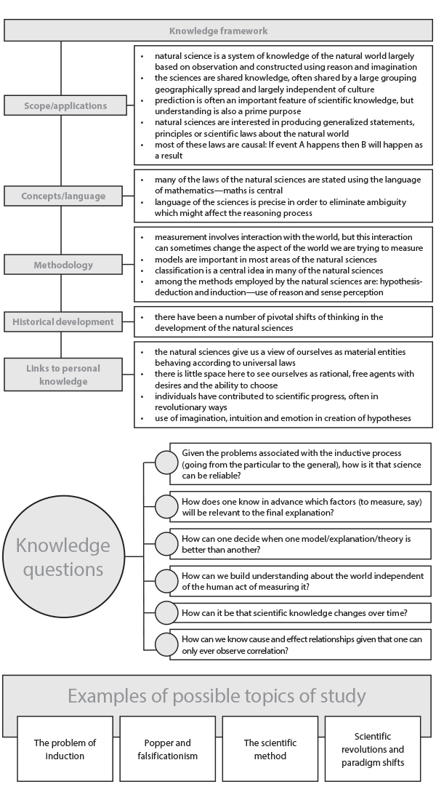

Knowledge framework for Human Sciences (zoom in to see better)

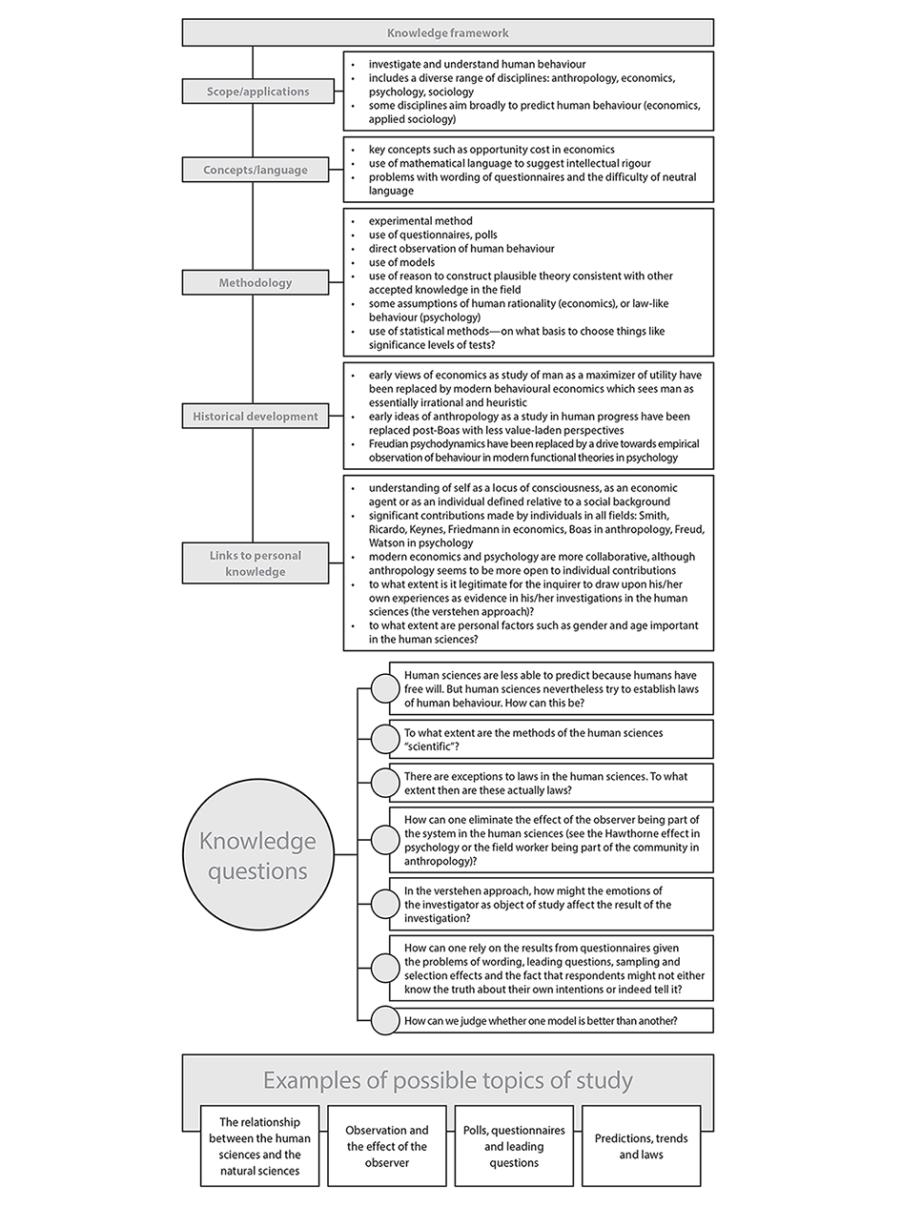

Knowledge framework for Mathematics (zoom in to see better)

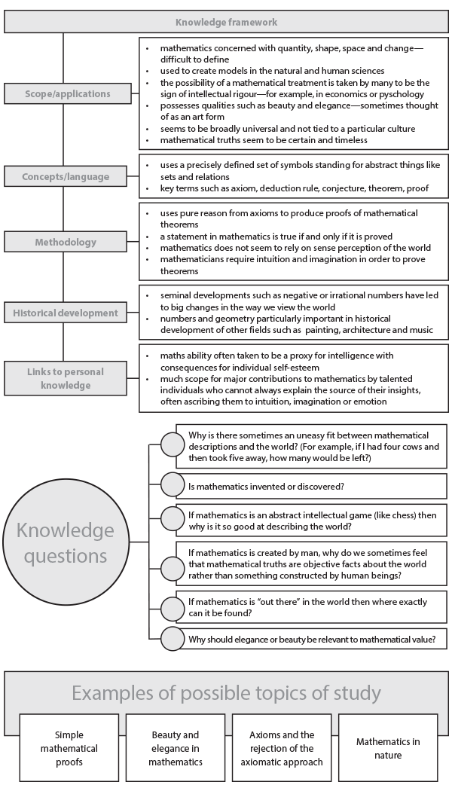

Knowledge framework for History (zoom in to see better)

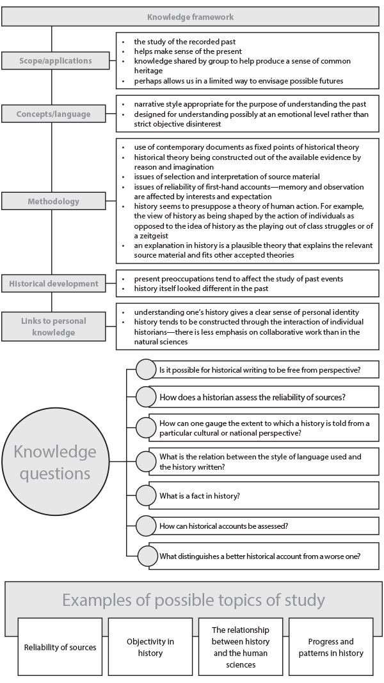

Knowledge framework for Ethics (zoom in to see better)

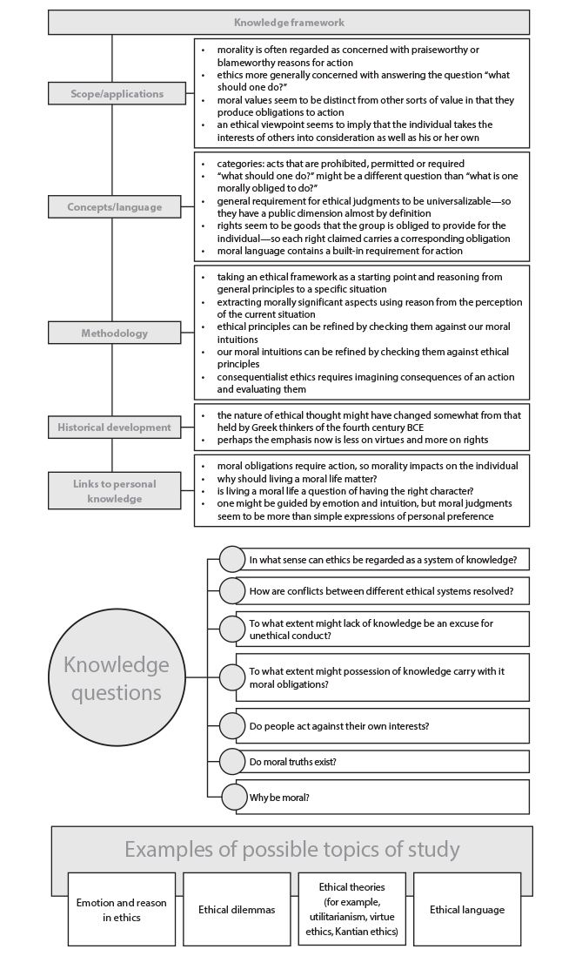

Knowledge framework for Indigenous knowledge systems (zoom in to see better)

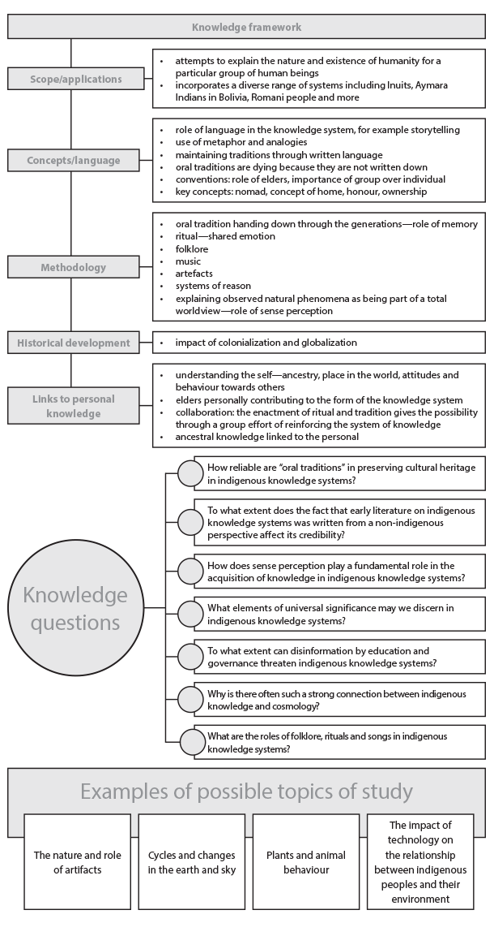

Knowledge framework for Religious knowledge systems (zoom in to see better)

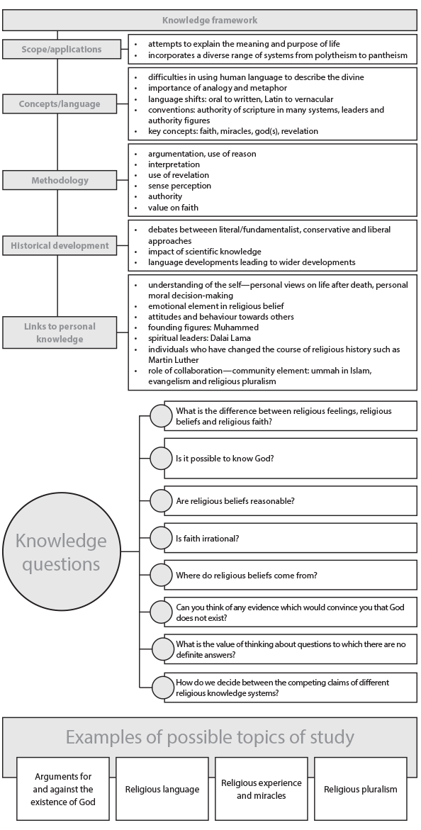

Knowledge framework for Arts (zoom in to see better)

